The
Quartzlight

A Newsletter of Jasper Evangelical Lutheran Church
Highland and First Parish

Pastor – Sue Grinde

Secretary – Carol Johnson Custodians – Doug & Lisa Petersen

Church Office 348-3276;

101 S. Spicer Ave., P.O. Box 306, Jasper, MN 56144

JANUARY, 2021

Good Riddance 2020

It was the best of times, it was the worst of times. It was 2020.

I think some of you are sighing a sense of relief that 2020 is over and bring on 2021. What will be different? Wil the way we have done things go back to normal? Will the new normal that we have been adjusting to and living into for the past almost 10 months be the way we continue to live?
Since March our pastors from the Shetek Conference meet every Thursday morning through Zoom. A few weeks ago this poem by Emily Dickinson was brought up.

A poem by Emily Dickinson entitled “I Dwell in Possibility”
I dwell in Possibility –
A fairer House than Prose –
More numerous of Windows –
Superior — for Doors –
Of Chambers as the Cedars –
Impregnable of eye –
And for an everlasting Roof

The Gambrels of the Sky –
Of Visitors — the fairest –
For Occupation — This –
The spreading wide my narrow Hands
To gather Paradise –

I want you to think about rather than look at our work as punishment for what we didn’t get done yesterday, today, or maybe even tomorrow, look at as a gift. Look at your hands, what have they done. What is one possibility you would like to see happen?

As I look back during the past 10 months, we have done good things. In June we started gathering in-person again. Even though numbers are small we are gaining an online presence. We have reached out to families with virtual VBS, we sent out pencil boxes with items in it and a prayer for our youth. Advent in A Bag were assembled for families to work through during our Advent season. Advent calendars and ornaments were sent to our Sunday School youth from all three churches. Phone calls made by various people reaching out and checking in with our members. The church is still being the church. We haven’t shut down or closed. We are still here.

So instead of looking back and thinking what was horrible during the last months of not being able to gather in-person for worship, not having our fall supper or Lefse baking days and bake sale, think what did go well. What did go well in your lives? Whatever that may be, give thanks to God for that. Blessings as we venture together in 2021.
Peace,

Pastor Sue

January Birthdays

Wayne Gertz 3
Bill Krapf 3
Tanya O’Leary 5
Karla Conrad 9
Gavin Johnson 9
Judi VandeVoorde 11
Edie Aas 13
Luella Haraldson 18
Clay Giesler 19
Case Thode 21 (2018)
Elizabeth Schneider 22
Samantha Smith 23
Lana Baerenwald 24
Daina Hansen-Shafer 24
Heather DeBates 28
Portia Martinson 28
Ana Jones 30
Rodney Reuland 31
Jane Schiefelbein 31

FIRST / HIGHLAND

JANUARY:

Roger Megard 1
Lane Ellefson 1
Bonnie Koch 2
MacKenzie Prins 2
Jean Powell 4
Katherine Konda 6
Justin Stoterau 14
Carol Johnson 21
Sigrun McGee 23
Collin Johnson 31

The Endowment committee will be giving scholarships to any current college member of our congregation. The deadline for the application is the third Sunday in January. (January 17th) Applications are on Carol’s desk or if you want one mailed or e-mailed, please let Carol know.

Contact Information for
Jasper Lutheran Church

Pastor: Sue Grinde
605-351-7155
PASTOR.JELC@vastbb.net

OFFICE 507-348-3276
jasperelc@iw.net

If anyone is interested in running our ipad for facebook live on Sunday mornings, please let Pastor Sue know. It would be greatly appreciated.

. Website and Facebook page. jasperelc.org – Jasper ELC – Feel free to post pictures and/or comments. Just remember to be kind.

Highland and First Lutheran also has a Facebook page. In Facebook, type First Lutheran Church, Sherman, SD.

If you want to be added to the “group” please let Pastor Sue or Nicole Stoterau know.

Due to the current health situation, we are postponing the Christmas program and Sunday school until January. The current plan is to practice the program January 3 and do the Facebook live performance January 10 - just slightly past the 12 days of Christmas.

Anyone interest in joining the community “Tuesday Morning Bible Study” group is more than welcome. Bible Study begins at 9:30 and lasts about an hour or so (depends on who is inclined to stay and visit for a while). Masks are mandatory and we are seated approximately 6 feet apart.

Goodness, it seems like the year just flew by even though so much has happened in the year 2020. Now we have a new beginning with the year 2021. With the “new beginning” comes our annual reports. There has been no date set for the annual meeting, however, if I could get them mid-month, it would be great. If it is easier, you can email them to me at jasperelc@iw.net.

The next Bloodmobile will be held on March 17th, from 12:30 – 6:30. You are giving, you must register on line. There are no more WALK-IN individuals taken. If you have any questions or concerns, please call Sandy Moose at 507-348-7456.

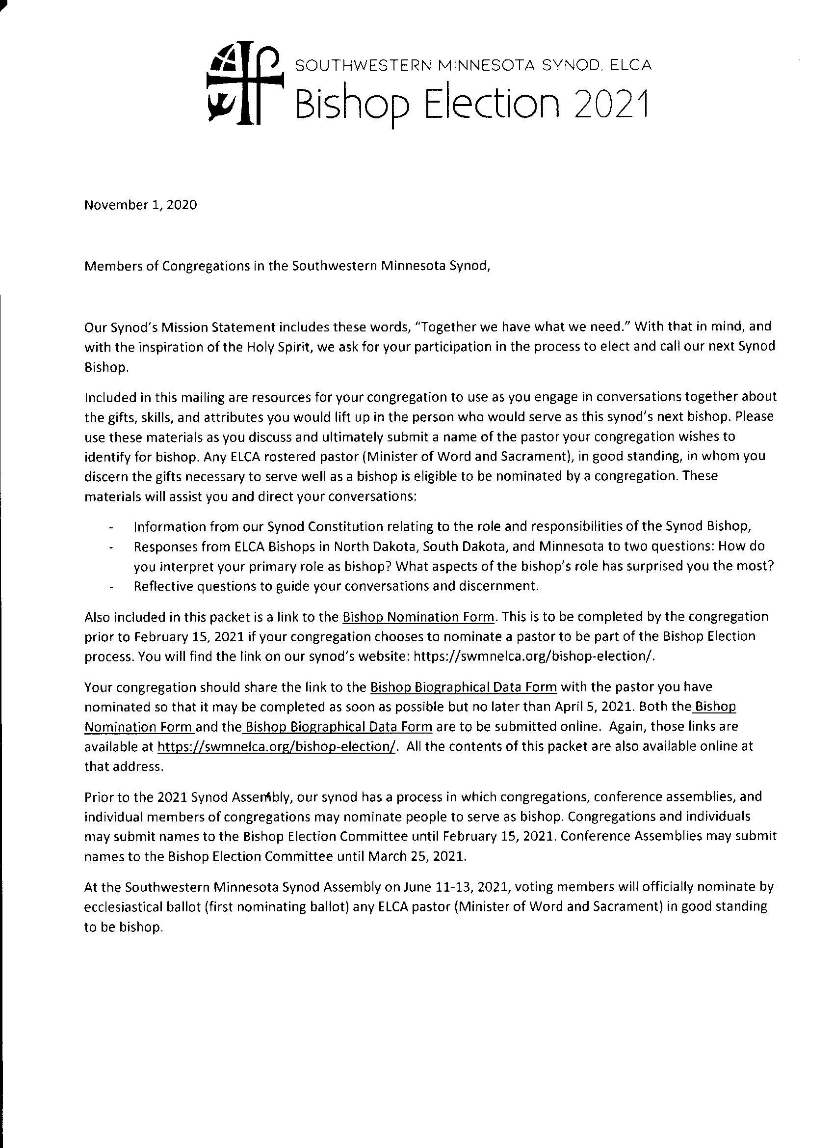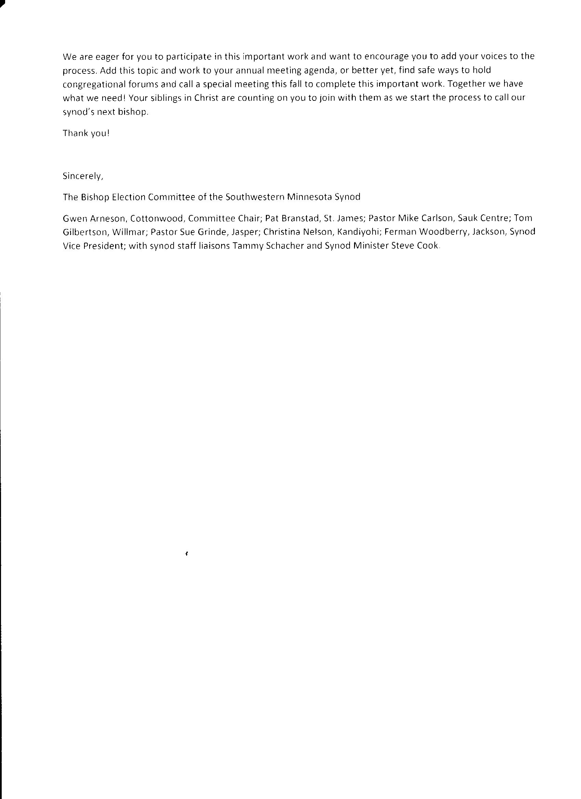

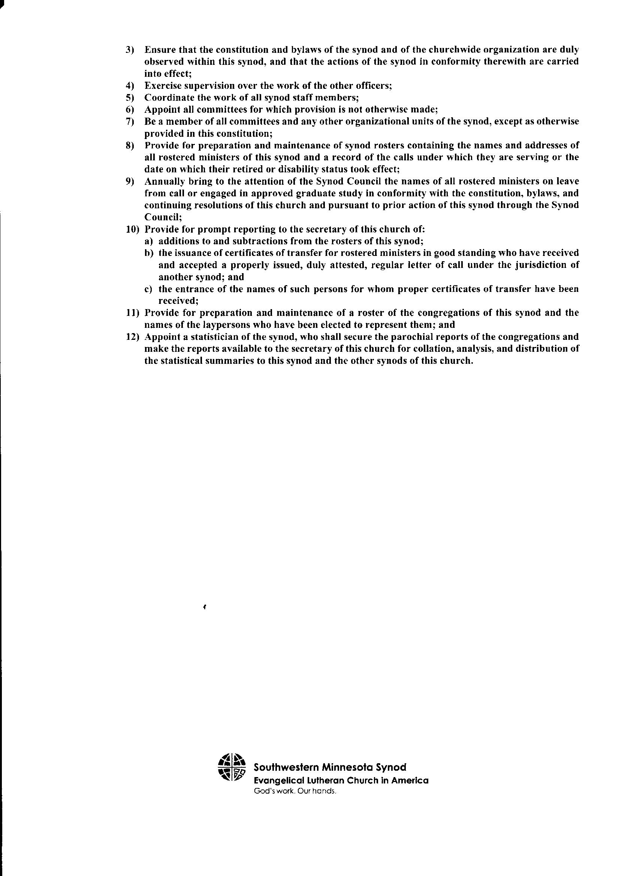

Thank you! Thank you! Thank you!
Our donors and congregations have been very supportive during this time.
We continue to need your help to start 2021 in a strong position as we move towards a summer of programming.

Help send kids to Camp…Become a Pelican Club or Timber Society member today. Pelican Club members support the ministry with a gift of $100 - $499 a year and Timber Society members give $500 or more a year. Thanks for your support!

As part of our “Building on the Foundation” campaign facility improvements, we are upgrading our water treatment facility. The exterior was done the first part of Dec. and now we’ll work on the interior and begin putting equipment in this winter. Next spring we’ll get it all operational and hooked into our current water lines as well as running a new line to the site for the Adult/Youth Lodge.

Events at camp!
(Go to shetek.org for more info.)
December 6 Scandinavian Drive through dinner was a huge success – 228 meals! Thanks to those who participated!

Jan. 8 – Friday, 8-10pm - Snowshoeing and
Stargazing, Come to camp for an evening of fun and learning.
Jan. 10 – Sunday, 3-4:30pm – Come out to learn
more about snow!
Jan. 15-17 – Friday – Sunday – Quilting/Crafting
Retreat – Bring your projects to camp and
enjoy time with other creative folks.
Jan 24 – Sunday – Family Ski/Snowshoe Day –
2-4pm – Bring the whole family!

Our “Building on the Foundation” capital campaign is slowly starting again. So far, we’ve raised $1,100,000 in gifts/pledges towards our $1,500,000 goal! Watch for more information about our progress as we begin 2021.
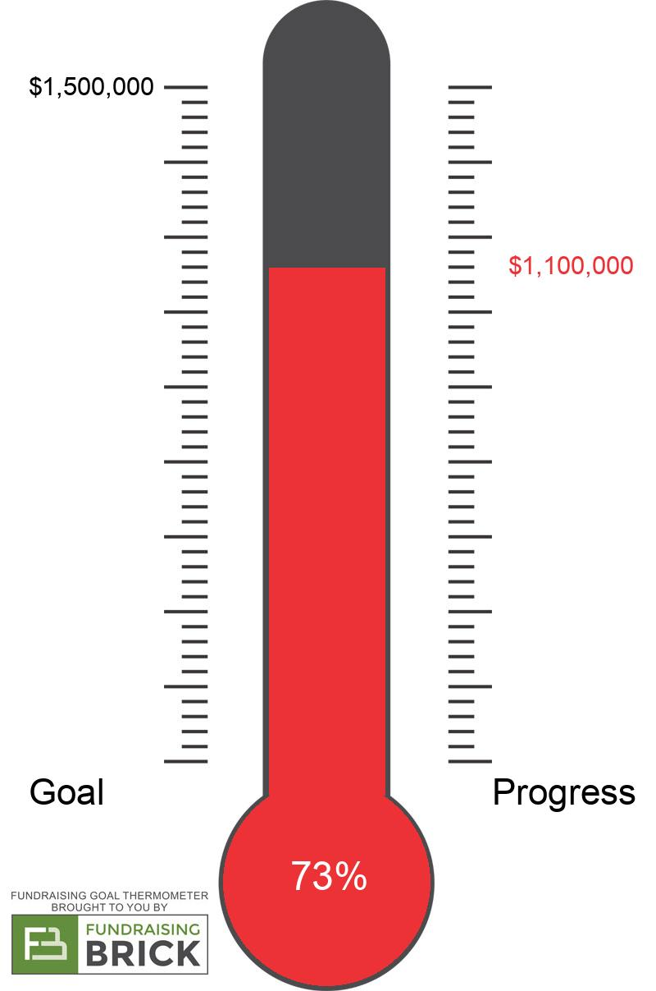
Shetek Lutheran Ministries Where Christ Renews and Empowers
14 Keeley Island Drive
Slayton, MN 56172 507-763-3567
camp@shetek.org
www.shetek.org
January 2021

COME AND

VISIT OUR

LIBRARY

Readers of Amish fiction will delight in The Adams County Trilogy by veteran author Jerry S. Eicher.

In the first book – Rebecca’s Promise – Rebecca Keim has just declared her love to John Miller and agreed to become his wife. But she’s haunted by her schoolgirl memories of a long ago love – a promise made and a ring given. Is that memory just a fantasy come back to destroy the beautiful present…or was it real?

When Rebecca’s mother sends her back to the old home community in Milroy to be with her aunt during and after childbirth, Rebecca determines to find answers that will resolve her conflicted feelings.

Faith, love and tradition all play a part in Rebecca’s divine destiny.

Readers who enjoyed Rebecca’s Promise will eagerly devour the next entry in this Amish series set in southern Ohio – Rebecca’ Return.

Rebecca Keim returns to Wheat Ridge full of resolve to make her relationship with John Miller work. But in her absence, John has become suspicious of the woman he loves. Before their conflict can be resolved, John is badly injured and Rebecca is sent back to Milroy to aid her seriously ill Aunt Leona.

In Milroy, Rebecca once again visits the old covered bridge over the Flatrock River, the source of her past memories and of her promise made so long ago.

Where will Rebecca find happiness? In Wheat Ridge with John, the man she has agred to marry…or should she stake her future on the memory that persists…and the ring she has never forgotten? Does God have a perfect will for Rebecca and is so how can she know that will?

Popular Amish fiction author Jerry Eicher finishes the Adam’s County Trilogy with Rebecca’s Choice, and intriguing story of a young couple’s love, a community of faith, and devotion to truth.

Rebecca Keim is now engaged to John Miller, and they are looking forward to life together. When Rebecca goes to Milroy to attend her beloved teacher’s funeral, John receives a mysterious letter accusing Rebecca of scheming to marry him for money. Determined to forsake his past jealousies and suspicions, John tries hard to push the accusations from his mind.

Upon Rebecca’s return, disturbing news quickly follows. She is named as the sole heir to her teacher’s three farms. But herre’s a condition – she must marry an Amish man. When John confronts Rebecca, she claims to know nothing. Soon Rachel kByler, the vengeful but rightful heir to the property, arrives and reveals secrets from the past. Now the whole community is reeling!

The Debt by Angela Elwell Hunt

After fleeing a painful and compromising past, Emma Rose Howard settled eagerly into the role of a pastor's wife. She and her husband, Abel, dedicated themselves to parenting a mega-church and influenced thousands of lives through its related ministries.

But when Emma Rose receives a phone call from a living, breathing remnant of her troubled past, she finds herself wondering if something in her life is woefully out of balance. The presence of this unexpected intruder soon threatens everything Emma Rose has believed about her calling, her marriage, and her relationship with God.

The Debt not only invites readers to embrace the painful heartache and incomparable joy that accompany a soul's redemption, but it challenges us to follow Christ to new and unexpected places.

This novel is very different from most on our library shelves, but the message is profound.

Just a reminder that everyone is welcome to the library at Jasper ELC. We do have some great books and I know that you would find something you would enjoy.

